##### LEGEND BLACK

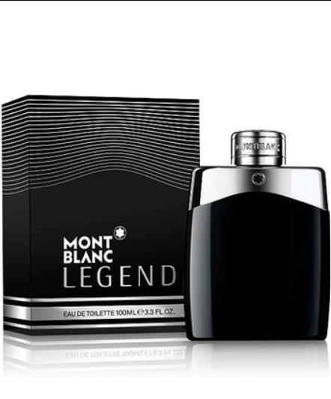

**Legend** by **Montblanc** is a Aromatic Fougere fragrance for men. **Legend** was launched in 2011. Legend was created by Olivier Pescheux and Celine Perdriel. Top notes are Lavender, Pineapple, Bergamot and Lemon Verbena; middle notes are Red Apple, Dried Fruits, oak moss, Geranium, Coumarin and Rose; base notes are Tonka Bean and Sandalwood.

The brand Mont Blanc presents a new men's fragrance in April 2011. Legend is dedicated to inspiring, virtuous and self-confident men who are courageous, passionate and authentic. Their fragrance is subtle but striking and masculine.

Olivier Pescheux, the perfumer behind this fresh fougere creation, tried to make the fragrance filled with contrasts, combining notes that evoke strength and tenderness, tradition and modernity. The composition opens with fresh aromatic tones of bergamot, lavender, pineapple leaf and exotic verbena (Litsea Cubeba). The heart emphasizes oakmoss note (evernyl molecule) merged with geranium, coumarin, apple, rose, and Pomarosa molecule (notes of dried fruit). The base contains sandalwood, tonka and evernyl.